Name _________________________________ AP Calculus
Section 5.5 Practice: Trapezoidal Rule

Show all your work!

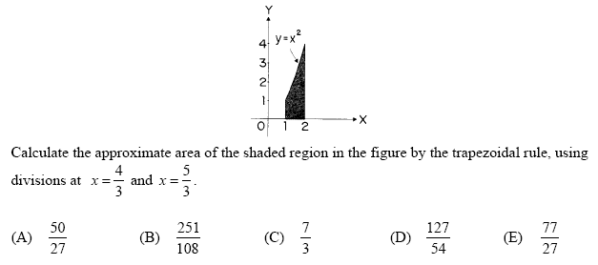
1.

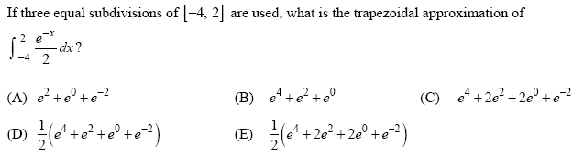
2.

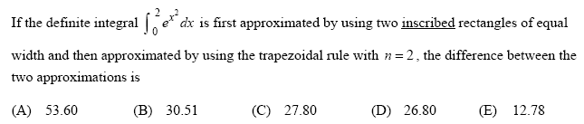
3.

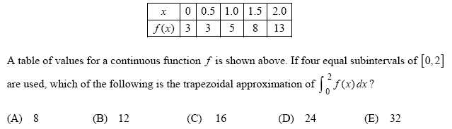
4.

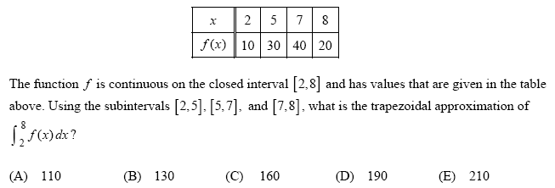
5.

